Technical Description

of a

Mechanical Pencil

Prepared By: Nicholas Lace

WRIT121 Fall 2012

# Introduction

For the technical description assignment, I have chosen a Pentel GraphGear 500 mechanical pencil. A mechanical pencil is a writing utensil that is designed to allow continuous application of a graphite substrate onto paper via an advance mechanism. A mechanical pencil will typically have a grip and a body to contain the moving parts. For an external view please see Figure 1. For the sake of convenience I will separate the description into the following organizational structure: writing tip, body, & lead advance mechanism.

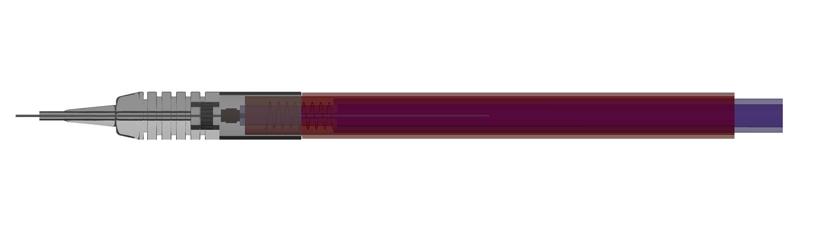

Body

Writing Tip

Lead Advance mechanism

Figure 1 External view of a GraphGear 500 pencil

# Writing Tip

The writing tip, Figure 2, directs the graphite substrate (pencil lead) and provides the user with a textured grip. The tip is comprised of a threaded textured shell, rubber retention ring, and a lead tube. The tip also provides a surface for the mechanism to disengage the chuck ring. The textured shell holds the lead tube and retention ring in place, as well as providing a threaded mating surface for the pencil body.

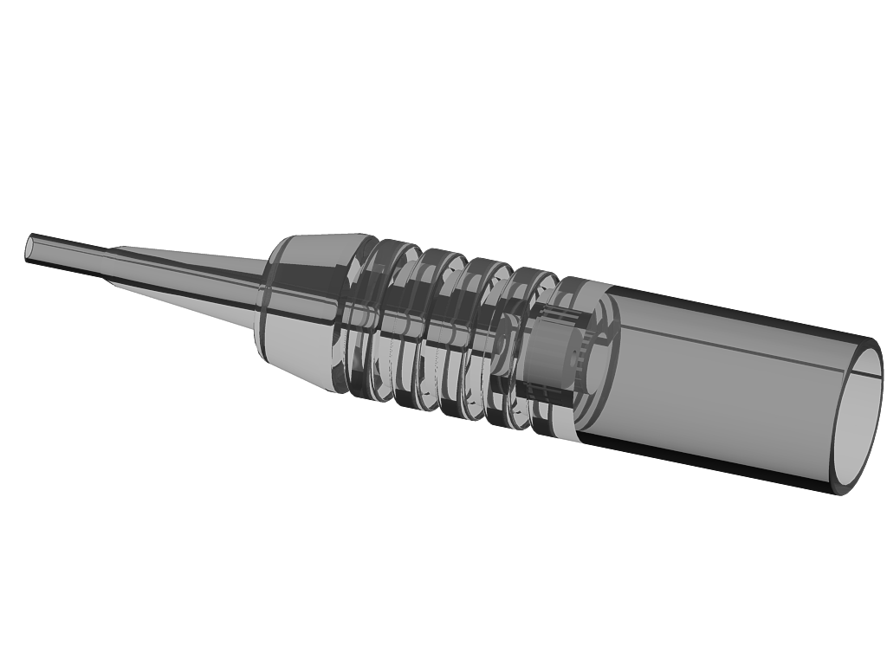

Textured Grip

Rubber Retention Ring

Lead Tube

Figure 2 Threaded writing tip body

# Body

The body, Figure 3, of the mechanical pencil is responsible for housing the lead advance mechanism and directing its movement into a linear fashion. It features a threaded mating surface for the writing tip, and a label indicating the size of lead the pencil is designed to use.

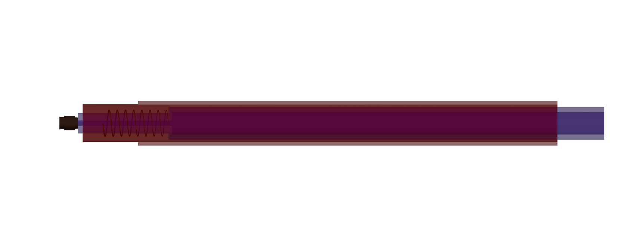

Threaded mating surface

Shell

Lead Advance Mechanism

Figure 3 Mechanical pencil body with lead advance mechanism closed.

# Lead Advance Mechanism

The lead advance mechanism consists of a spring, chuck, chuck ring, and body. The spring pulls the chuck into the chuck ring, restricting the movement of the lead. See Figure 4. Applying pressure to the exposed end operates the mechanism. This pressure compresses the spring, which simultaneously advances the lead and opens the chuck. When pressure is released, the spring returns to its extended position. Pulling the chuck into the chuck ring. The chuck ring moves with this assembly, and is disengaged when the assembly pushes it into the writing tip.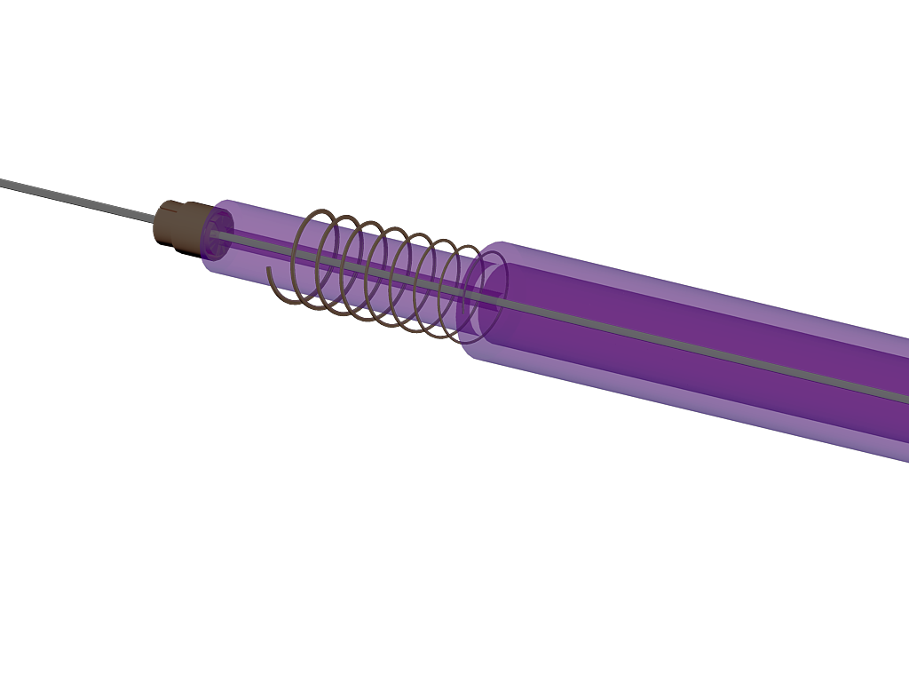

Spring

Body

Chuck Ring

Chuck

Figure 4 Chuck & Chuck Ring of a mechanical pencil

# One Cycle

The user of the pencil depresses the lead advance mechanism at the end opposing the writing tip. As the spring compresses, the pencil lead advances into the writing tip by a small amount, the chuck then extends out of the chuck ring. Now free of the chuck ring, the chuck expands releasing its grip on the lead. When the user releases the lead advance mechanism, the now compressed spring returns the assembly to its home position. Pulling the chuck into the chuck ring, tightening the chuck around the lead. With the lead now fixed in the chuck, the pencil can now be used without fear of the lead retracting into the mechanism when the user applies pressure.

# Summary

Placeholder for actual summary…